SIMATS ENGINEERING (SAVEETHA SCHOOL OF ENGINEERING) Department of Computer Science and Engineering
CO2_AT1 — CHART CONSTRUCTION TEST
Course Code: | DSA06 | Course Title: | Data Handling and Visualization
CO Assessed: | CO2 – Construction (BL3) | Assessment: | Assessment Tool 1 – Chart  Construction
Weightage: | 20% of CIA | Total Marks: | 25 (5 Questions × 5 Marks)
CO2 Statement: | Apply appropriate chart construction techniques — correct chart type, axes, scales, and calculations — to accurately represent given data.(BL3)
Student Name: | K. Amrutha Sandhya | Reg. No.: | 192524270
Section / Batch: | AIDS | Date: | 30-7-2026

Code of Conduct
I K. Amrutha Sandhya(192524270) (Name / Reg No) certify that this submission is my original work and that I have adhered to the guidelines specified for this assessment. I understand that any violation of academic integrity rules will result in disciplinary action.
Signature of the Student: Amrutha

Instructions
• This test contains 5 questions, each carrying 5 marks. Total: 25 Marks.
• No negative marking. Unanswered questions carry zero marks.
• No calculators or electronic devices permitted.
• Duration: 75 minutes.
• Graph paper or a ruler is recommended for accurate, to-scale drawing.
• Show all calculations (e.g., percentages, angles, bin ranges, five-number summaries) as part of your answer. • Every chart must include a title, correctly labeled axes, and a legend where applicable.

Annexure A – CHART CONSTRUCTION
Rubrics for Calculation ASSESSMENT RUBRIC
AT1 — Chart Construction Test
CO2 · BT3: Apply ·
This rubric is used to assess student responses to the CO2-AT1 Chart Construction Test, in which students are given a small dataset and must construct an accurate, correctly labeled chart of a specified type.
Criteria | Weightage | Level 4 –  Exemplary | Level 3 –  Proficient | Level 2 –  Developing | Level 1 –  Beginning
Understanding of Concepts | 25% | Demonstrates  thorough,  accurate  understanding of the correct chart type, and the  axes, scale, and elements required to construct it for the given data. | Good  understanding of the required chart type and  construction  elements, with  only minor gaps. | Basic  understanding of chart  construction, but with some  misconceptions about the correct chart type, axes, or scale. | Poor  understanding of core construction concepts; selects a chart type or  elements  fundamentally  unsuited to the  data.
Explanation | 25% | Shows detailed, clearly worked  calculations (e.g., angles, bin  ranges, five  number  summary) and  explains each  construction step. | Shows clear  calculations and construction  steps, with  adequate  explanation for  most parts. | Calculations or  construction  steps are shown but incomplete, or explanations are superficial. | Little or no  working shown; calculations and construction  steps are missing or unexplained.
Application | 20% | Effectively applies chart construction techniques to  produce a  complete,  accurate chart  correctly matched to the data. | Applies  construction  techniques to  produce a correct chart, with only  minor errors. | Limited  application of  construction  techniques; the chart partially  represents the  data but has  notable errors. | Fails to apply  appropriate  construction  techniques; the chart does not  correctly  represent the  data.
Organization | 15% | The chart is  neatly and  logically | The chart is well organized, with  only minor issues | Basic  construction;  required elements | Poorly  constructed; the chart is missing

Criteria | Weightage | Level 4 –  Exemplary | Level 3 –  Proficient | Level 2 –  Developing | Level 1 –  Beginning
 |  | constructed, with a title, correctly  labeled axes, a  legend where  applicable, and  elements in a  clear order. | in labeling,  legend, or layout. | (title, axes,  legend) are  present but poorly arranged or partly missing. | key elements  such as a title,  axis labels, or a legend.
Accuracy | 10% | The chart is  completely  accurate — all  values,  proportions,  scales, and  calculations  correctly match the given data. | Mostly accurate, with only minor  omissions or a  small error in one value or  calculation. | Partially correct; some plotted  values,  proportions, or  calculations are missing or  incorrect. | Largely  inaccurate; major errors in plotted values,  proportions, or  calculations  relative to the  given data.

Scoring Guide
For each criterion, award a performance level (1–4) based on the descriptors above. Multiply the level achieved (as a percentage of 4, i.e., Level 4 = 100%, Level 3 = 75%, Level 2 = 50%, Level 1 = 25%) by the criterion's weightage, then sum across all five criteria to obtain the total score out of 100%.
Faculty In-charge | Course Coordinator | Head of Department
Signature: _______________ | Signature: _______________ | Signature: _______________
Date: ___________________ | Date: ___________________ | Date: ___________________

Problem 1 — Bar Chart — Basic Construction
Data: Monthly sales (units): Jan = 120, Feb = 150, Mar = 90, Apr = 200, May = 175. Task: Construct a bar chart to represent monthly sales. Label both axes, include a chart title, and keep
the months in chronological order.
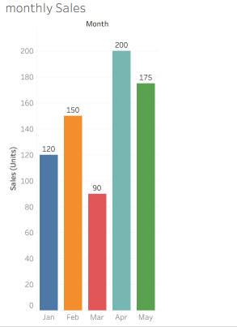
Problem 22 — Diverging Color Scale — Profit/Loss
Data: Monthly profit/loss ($'000): Jan=−15, Feb=+8, Mar=−3, Apr=+22, May=+5, Jun=−10.
Task: Construct a bar chart using a diverging color scale (e.g., one color for loss, another for profit) to
represent this data, clearly marking the zero baseline.
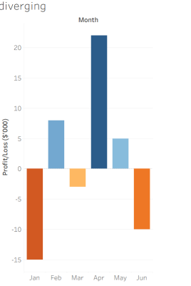
Problem 23 — Treemap — Proportional Area
Data: Revenue by product category: Electronics=$400K, Clothing=$250K, Books=$150K, Toys=$100K,
Home=$100K.
Task: Construct a treemap where each rectangle's area is proportional to that category's share of total
revenue. Show your calculation of each category's percentage share.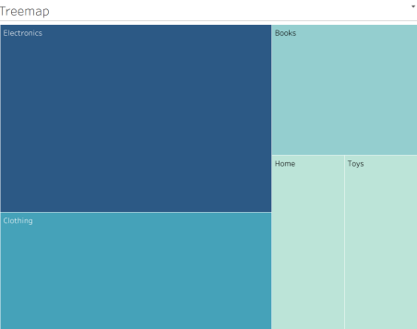
Problem 24 — Combination Chart — Bar + Line
Data: Monthly sales (units) and average price ($): Jan=(100,20), Feb=(120,22), Mar=(90,25),
Apr=(150,21), May=(130,23), Jun=(160,24).
Task: Construct a chart combining a bar chart (units sold) with a line chart (average price) across the six
months. Explain why you would avoid using a dual y-axis and how you would represent both variables
clearly instead.
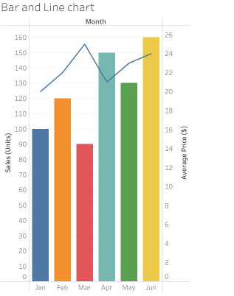
Problem 25 — Small Multiples Construction
Data: Weekly sales (units) for 4 regions over 4 weeks: Region A: 40, 55, 50, 65 Region B: 30, 35, 45, 40
Region C: 60, 58, 70, 75 Region D: 20, 25, 22, 30
Task: Construct a set of four small-multiple line charts, one per region (rather than one overlaid chart),
and briefly justify this design choice over a single combined chart.